# **University Scholarship Management System Entity Relationship Diagram**

Group Members: Chukwuebuka Ernest-Opara, Malavkumar Patel, Sagun Raj Lage, Sai Sravanthi Racharla, Vishal Kumar Yadav

**Description of the System**

The description of the University Scholarship Management System Project is given below:

* A student has only one major, but there can be many students who have the same major.
* Every major is offered by its specific department, and a department can offer more than one majors.
* It is up to a department to provide scholarships. And each department has its own set of scholarships that it can provide to its students. Thus, a scholarship can belong to only one department.
* Although a department has a number of scholarships, it can only offer one scholarship to each student. However, if funds are available, a single scholarship can be provided to more than one student. So, a student can receive only one scholarship, while many students can receive the same scholarship.
* A sponsor is responsible to fund a scholarship. The sponsor can either choose to fund a single scholarship, or they can fund multiple scholarships. Also, a single scholarship can have multiple sponsors funding it.

**Entities and Attributes**

The entities involved in the system along with their attributes are listed below:

* STUDENT: student_id, first_name, last_name, level, date_of_birth, age, address, country, gpa, scholarship_id, major_id
* MAJOR: major_id, name, duration, accreditation, department_id
* DEPARTMENT: department_id, name, phone, chairman, email, website
* SCHOLARSHIP: scholarship_id, name, criteria, amount, department_id
* SPONSOR: sponsor_id, name, phone, email, type, address, scholarship_id

**Relationships**

The relationships that exist between the entities are listed below:

* STUDENT has MAJOR.
* STUDENT receives SCHOLARSHIP.
* DEPARTMENT offers MAJOR.
* DEPARTMENT provides SCHOLARSHIP.
* SPONSOR funds SCHOLARSHIP.

**Cardinalities**

The cardinalities that exist between each of the relationships are listed and described below:

* **STUDENT has MAJOR:** There exists a many-to-one (1:M) relationship between STUDENT and MAJOR since each student has only one major, and many students can have a single major.
* **STUDENT receives SCHOLARSHIP:** There exists a many-to-one (1:M) relationship between STUDENT and SCHOLARSHIP since a student can receive only one scholarship, and many students can receive the same scholarship.
* **DEPARTMENT offers MAJOR:** There exists a one-to-many (1:M) relationship between DEPARTMENT and MAJOR since a department can offer many majors, and a major can be offered by only one department.
* **DEPARTMENT provides SCHOLARSHIP:** There exists a one-to-many (1:M) relationship between DEPARTMENT and SCHOLARSHIP as a scholarship can be provided by only one department, but each department can provide multiple scholarships.
* **SPONSOR funds SCHOLARSHIP:** There exists a many-to-many (M:N) relationship between SPONSOR and SCHOLARSHIP since many sponsors can fund one scholarship, and many scholarships can be funded by one sponsor.

**Entity Relationship Diagram**

The entity relationship diagrams of the system are given below in Chen model and Crow’s Foot model.

**Chen Model**

The entity relationship diagram in Chen model is given below:

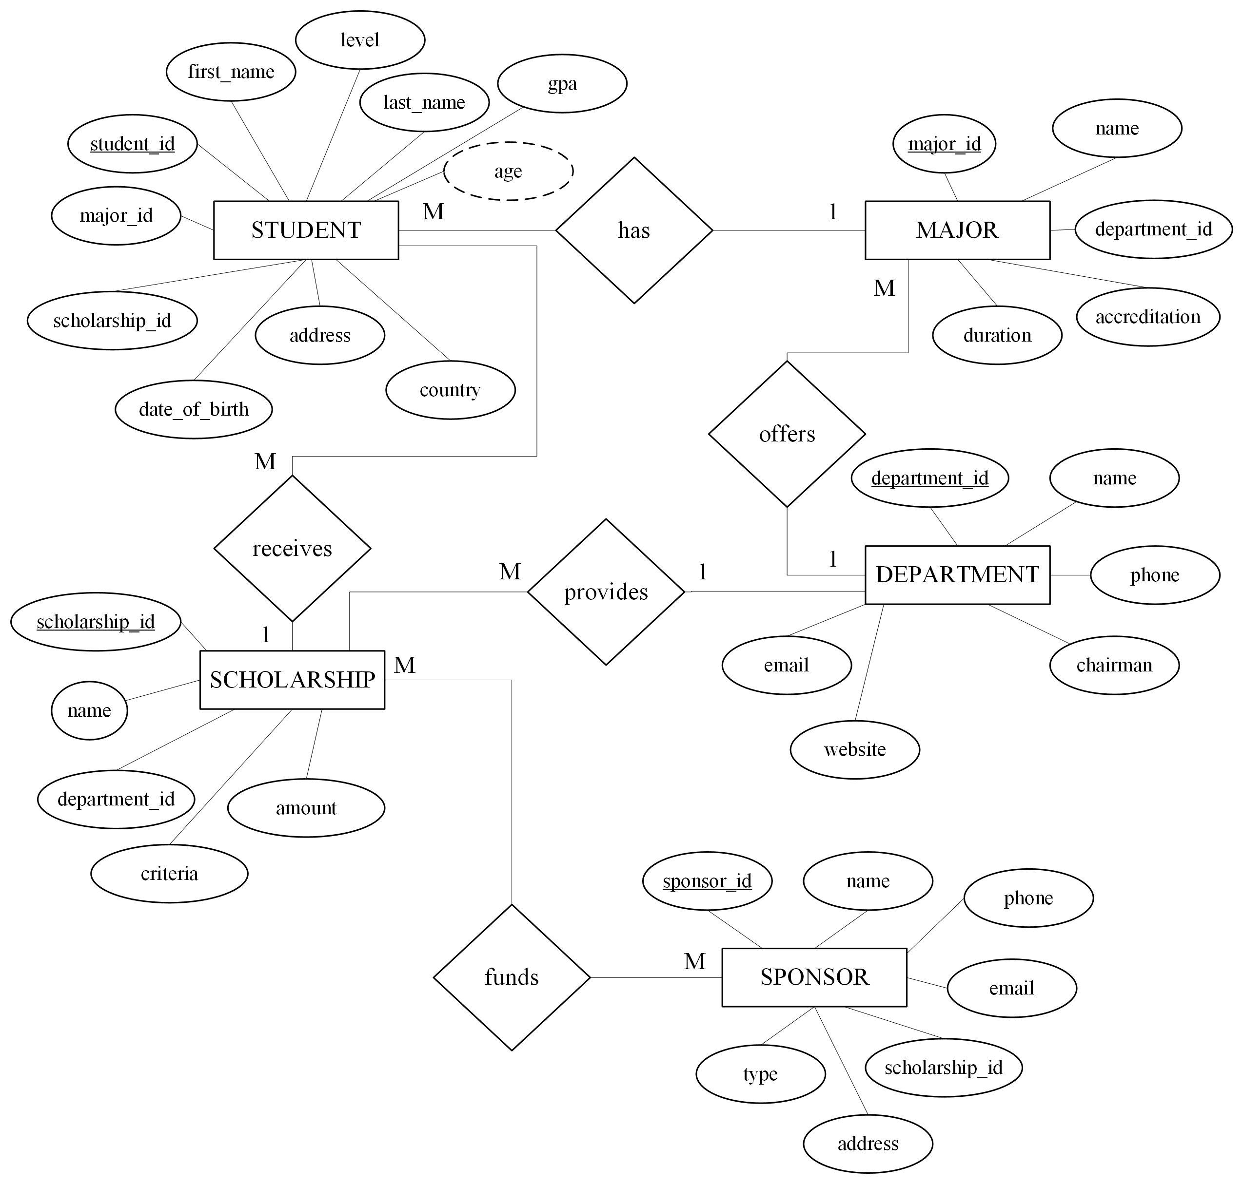

Figure : ER Diagram in Chen Model

**Crow’s Foot Model**

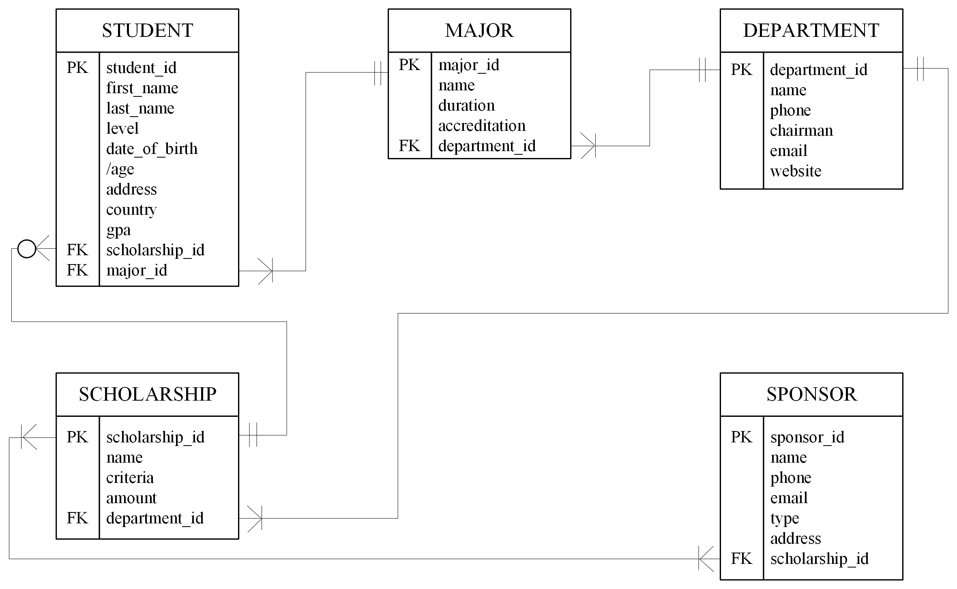The entity diagram in Crow’s Foot model is given below:

Figure : ER Diagram in Crow’s Foot Model

**Resolution of Many-to-Many Relationship**

In the given diagrams, it can be seen that there exists a many-to-many relationship between SCHOLARSHIP and SPONSOR. This can be resolved by including a bridge table named SCHOLARSHIP_SPONSOR that will consist of scholarship_id and sponsor_id as foreign keys to break down the many-to-many relationship into many-to-one relationship between SCHOLARSHIP and SCHOLARSHIP_SPONSOR and one-to-many relationship between SCHOLARSHIP_SPONSOR and SPONSOR. Also, both of those foreign keys are used together to form a unique composite primary key. This resolution is depicted in the ER diagram given below:

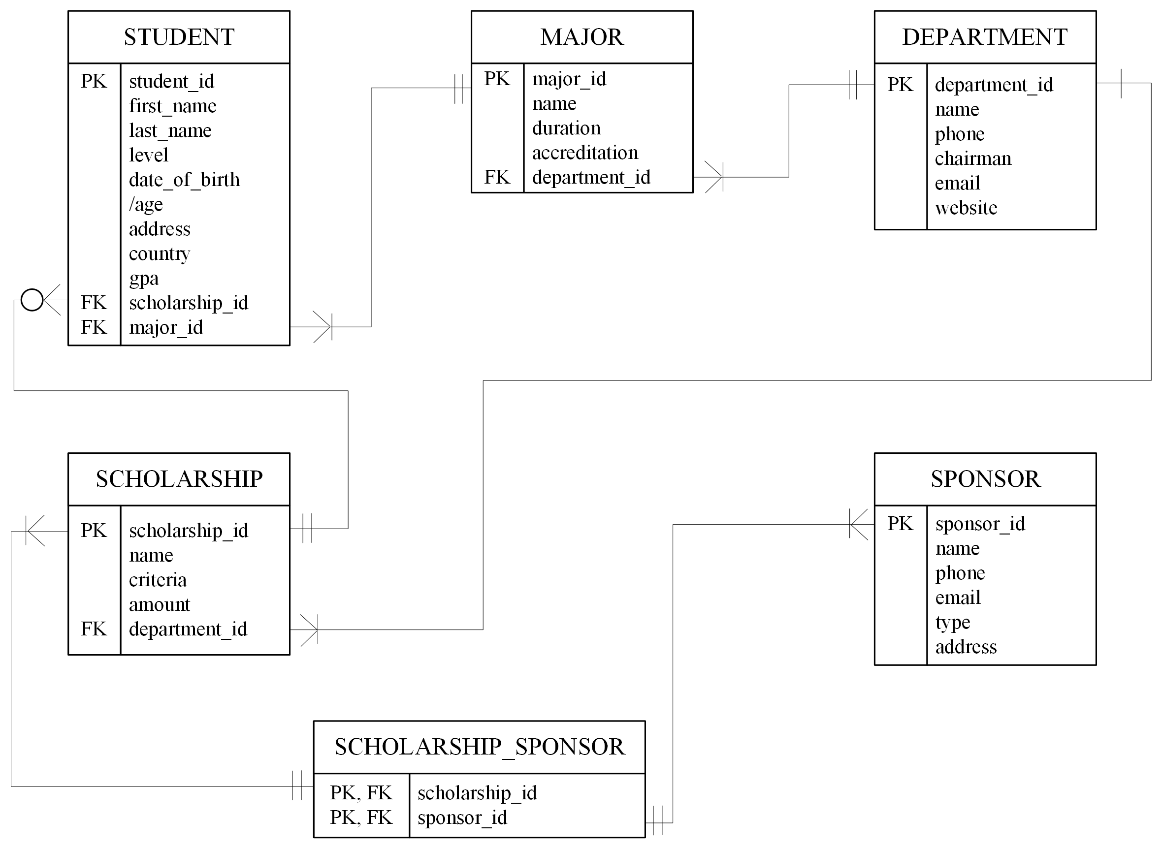

Figure : ER Diagram With SCHOLARSHIP_SPONSOR Bridge Table